Lesson 3 Demo 2: Image Tagging

This section will guide you to:

* Tag an image referenced by image ID, name, and repository

**Step 1:** Pull a Docker image

* Use the following command to pull the latest nginx image:

*sudo docker pull nginx:latest*

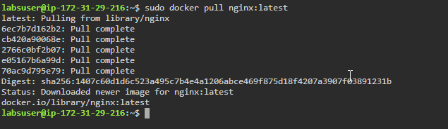

* List all the running images and check the newly pulled image:

*sudo docker images*



**Step 2**: Tag an image referenced by Image ID

* Use the following command to tag the *nginx* image, referenced by Image ID, into the **demo** repository with **version1.0**:

*sudo docker tag IMAGE_ID demo/nginx_img:version1.0*

***Note:*** *Replace IMAGE_ID with the Image ID of your nginx image from step 1.*

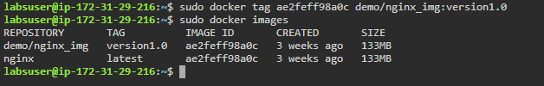

**Note:** Use *sudo docker images* command to see the newly tagged image under **demo/nginx_img** repository.

**Step 3**: Tag an image referenced by name

* Use the following command to tag the *nginx* image, referenced by Image name, into the **demo** repository with **version2.0**:

*sudo docker tag IMAGE_NAME demo/nginx_img:version2.0*

***Note:*** *Replace IMAGE_NAME with the Name of your nginx image from step 2.*

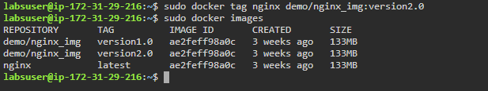

**Note:** Use *sudo docker images* command to see the newly tagged image under **demo/nginx_img** repository.

**Step 4**: Tag an image referenced by name and tag

* Use the following command to tag the *nginx* image, referenced by name and tag, into the **demo** repository with **version3.0**:

*sudo docker tag IMAGE_NAME:IMAGE_TAG demo/nginx_img:version3.0.latest*

***Note:*** *Replace IMAGE_NAME and IMAGE_TAG with the Name and Tag of your nginx image from step 3.*

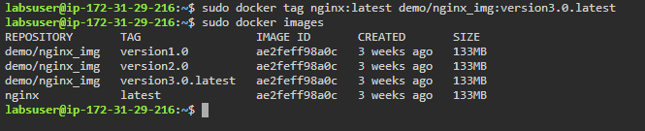

**Note:** Use *sudo docker images* command to see the newly tagged image under **demo/nginx_img** repository.

**Step 5**: Tag an image for a private repository

* Use the following command to tag an image for a private repository:

*sudo docker tag IMAGE_ID myregistry:5000/demo/nginx_img:version4.0*

***Note:*** *Replace IMAGE_ID with the Image ID of your nginx image from step 4.*

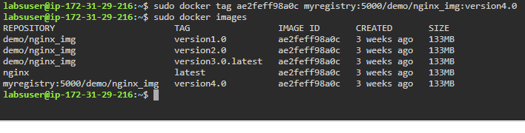

**Note:** Use *sudo docker images* command to see the newly tagged image under **myregistry:5000/demo/nginx_img** repository.